

**Project Report on**

***“Company/Business System Network Design”***

**Submitted To:**

**Md. Rashid Al Asif**

Assistant Professor

Department of CSE

University of Barishal

**Submitted By:**

**Roni Howlader**

Student ID:02-002-14

Batch: Basic Computer Networking-002

***Submission Date: 19.11.204***

# Abstract

This report presents a comprehensive overview of the Company System Network Design, executed through Cisco Packet Tracer, aiming to facilitate the expansion of a trading floor support center into a new facility. The primary goals of this project are centered around formulating and executing a robust, scalable, and forward-looking network infrastructure. The hierarchical model has been employed, integrating redundancy measures at each layer for enhanced reliability. Key features include the incorporation of dual Internet Service Providers (ISPs) to ensure uninterrupted internet connectivity, establishment of wireless networks for individual departments, creation of distinct VLANs and subnets, and the implementation of Open Shortest Path First (OSPF) for routing. Configuration specifics encompass the setup of DHCP servers, assignment of static IP addresses, implementation of Secure Shell (SSH) for secure access, and Port Address Translation (PAT) for managing outbound connections. The report underscores the significance of rigorous testing and verification processes, ensuring the successful deployment of a resilient network infrastructure that not only fulfills existing business requirements but also strategically positions the organization for future technological advancements and expansion.

Table of Contents

Abstract 2

1. Introduction 4

2. Network Design 5

3. Routing Configuration 8

4. Switching Configuration 11

5. Inter-VLAN Routing 13

6. Security Measures 14

7. Quality of Service (QoS) 16

8. Monitoring and Management 16

9. Testing and Validation 17

10. Results and Evaluation 19

11. Conclusion 20

12. Future Work 20

13**.** References 21

14. Appendices 21

**TABLE OF FIGURES**

FIGURE 1:TOPOLOGY OF FULL NETWORK .......................................................................................................................... 5FIGURE 2:ICMPPDU CHECK ...................................................................................................................................... 17

FIGURE 3: TRACEROUTE SUCCESSFUL ............................................................................................................................. 18FIGURE 4:DHCPIP ALLOCATION ................................................................................................................................. 18FIGURE 5: PERFORMANCE MEASURE THROUGH PING TIME ................................................................................................. 19

# Introduction

## Background

Amidst the dynamic landscape of contemporary computer networks, the "Company System Network Design" initiative addresses the pressing need for a resilient network infrastructure finely tuned to bolster the functionalities of an expanding company or business center. With the center's growth and relocation to a new facility, the strategic significance of network routing and switching takes center stage, playing a crucial role in guaranteeing smooth communication, streamlined data transfer, and dependable access to resources. This project concentrates on navigating the intricacies inherent in developing an efficient and forward-looking network, leveraging Cisco Packet Tracer. The endeavour closely aligns with the specific requirements and expansion strategies of the trading floor support center.

## Objectives

The primary objectives of the "Company System Network Design" initiative are clearly outlined to cater to the unique demands of the company's network infrastructure. The project aims to establish a hierarchical network model incorporating redundancy measures at every layer. It seeks to establish connections with a minimum of two Internet Service Providers (ISPs) to enhance internet reliability, deploy wireless networks tailored for specific departments, allocate distinct Virtual Local Area Networks (VLANs) and subnets to ensure secure communication, and configure routing protocols, security protocols, and advanced functionalities like Secure Shell (SSH) and Port Address Translation (PAT). By achieving these objectives, the project aims to develop a scalable, resilient, and forward-looking network infrastructure that not only fulfils current operational needs but also anticipates and accommodates the future growth and technological advancements of the company.

# Network Design

## Topology

The network configuration simulated in Packet Tracer for the "Company System Network Design" project adheres to a hierarchical model, prioritizing efficiency, scalability, and redundancy. The design encompasses three layers: the core layer, distribution layer, and access layer. In the core layer, redundancy is established by deploying two routers and two multilayer switches, interconnected to facilitate seamless data routing. The distribution layer features switches responsible for linking distinct departments, each assigned to its dedicated Virtual Local Area Network (VLAN). Finally, the access layer accommodates end-user devices, such as PCs and wireless access points, connecting to the switches. This topology ensures a well organized and structured network layout, fostering effective management and facilitating future expansion.

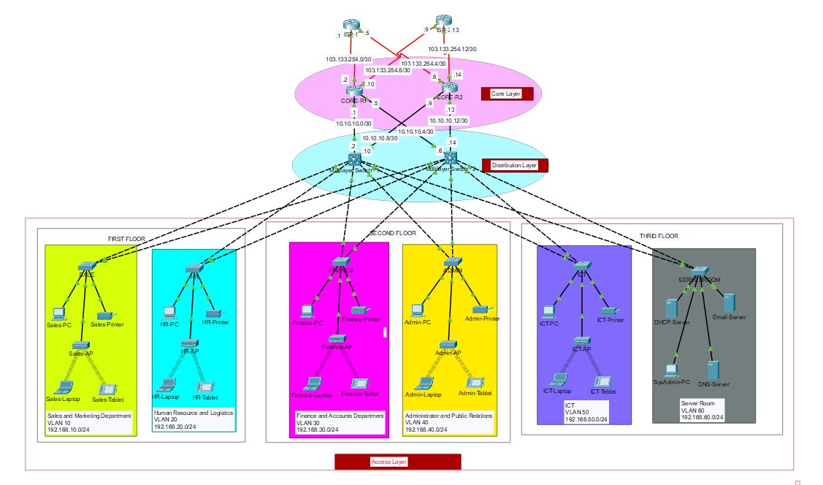

*Figure 1:Topology of full network*

## Components

The network design for the project incorporates the following devices:

1. **Routers (4):**
   * 2 ISP router for upstream connectivity.
   * Positioned at the core layer for redundancy. o Connect to both ISPs for internet connectivity.
   * Configured with static, public IP addresses from ISPs.
2. **Multilayer Switches (2):**
   * Deployed at the core layer to provide redundancy and efficient routing. o Configured for both switching and routing functionalities. o Assigned IP addresses to enable inter-VLAN routing.
3. **Distribution Layer Switches (Multiple):**
   * Connect individual departments to the core layer.
   * Facilitate communication within respective VLANs.
4. **End-User Devices (PCs):**
   * Deployed at the access layer.
   * Connected to distribution layer switches for departmental access.
5. **Cisco Access Points (APs):**
   * Positioned at the access layer to provide wireless connectivity.
   * Ensure wireless network availability in each department.
6. **DHCP Servers (1):**
   * Located in the server room.
   * Dynamically allocate IP addresses to end-user devices.
7. **Server Room Devices (Servers, etc.):**
   * DNS server, HTTP server etc. o Devices in the server room are allocated static IP addresses. o These devices may include servers, storage units, and networking equipment.

These devices collectively form a structured and well-organized network architecture, integrating redundancy, efficient routing, and secure communication to meet the specific requirements of the trading floor support center's operations.

## IP Addressing Scheme

Provide details about the IP addressing scheme applied to the network.

**Base Network:**192.168.0.0/22

**First floor:**

|  |  |  |  |  |
| --- | --- | --- | --- | --- |
| **Department** | **Network Address** | **Subnet mask** | **Host Address Range** | **Broadcast Address** |
| **Sales &**  **Marketing** | 192.168.10.0 | 255.255.255.0/24 | 192.168.10.1 to  192.168.10.254 | 192.168.10.255 |
| **HR and**  **Logistic** | 192.168.20.0 | 255.255.255.0/24 | 192.168.20.1 to  192.168.20.254 | 192.168.20.255 |

## Second Floor

|  |  |  |  |  |
| --- | --- | --- | --- | --- |
| **Department** | **Network Address** | **Subnet mask** | **Host Address Range** | **Broadcast Address** |
| **Finance & Accounts** | 192.168.30.0 | 255.255.255.0/24 | 192.168.30.1 to  192.168.30.254 | 192.168.30.255 |
| **Admin &**  **Public**  **Relations** | 192.168.40.0 | 255.255.255.0/24 | 192.168.40.1 to  192.168.40.254 | 192.168.40.255 |

## Third floor

|  |  |  |  |  |
| --- | --- | --- | --- | --- |
| **Department** | **Network Address** | **Subnet mask** | **Host Address Range** | **Broadcast Address** |
| **ICT** | 192.168.50.0 | 255.255.255.0/24 | 192.168.50.1 to  192.168.50.254 | 192.168.50.255 |
| **Server** | 192.168.60.0 | 255.255.255.0/24 | 192.168.60.1 to  192.168.60.254 | 192.168.60.255 |

## Core Router and L3 SW

|  |  |  |  |  |
| --- | --- | --- | --- | --- |
| **No** | **Network Address** | **Subnet mask** | **Host Address Range** | **Broadcast Address** |
| **Core R1-**  **MLTSW1** | 10.10.10.0 | 255.255.255.252 | 10.10.10.1 to  10.10.10.2 | 10.10.10.3 |
| **Core R1-**  **MLTSW2** | 10.10.10.4 | 255.255.255.252 | 10.10.10.5 to  10.10.10.6 | 10.10.10.7 |
| **Core R2-**  **MLTSW1** | 10.10.10.8 | 255.255.255.252 | 10.10.10.9 to  10.10.10.10 | 10.10.10.11 |
| **Core R2-**  **MLTSW2** | 10.10.10.12 | 255.255.255.252 | 10.10.10.13 to  10.10.10.14 | 10.10.10.12 |

**Public IP between Core and ISP:**

103.133.254.0/30

103.133.254.4/30

103.133.254.8/30

103.133.254.12/30

# Routing Configuration

## Router Configuration

Basic Router Configuration

|  |
| --- |
| conf t # Enters global configuration mode hostname CORE-R2 # Sets the hostname to CORE-R2 line console 0 # Enters console line configuration mode password cisco # Sets the console password to 'cisco' login # Enables login on the console line exit # Exits console line configuration mode  enablepassword cisco # Sets the enable password to 'cisco' *no* ip domain-lookup # Disables DNS lookup for incorrectly entered commands banner motd # NO Unauthorised Access!!!# # Sets a message of the day (MOTD) banner *service*password-encryption # Encrypts passwords in the configuration do wr # Writes the configuration to memory  ip domain name cisco.net # Configures the domain name for DNS resolution username admin password cisco # Creates a local user 'cisco' with password 'cisco' crypto key generate rsa # Generates an RSA key pair for SSH 1024 # Specifies the key size as 1024 bits line vty 0 15 # Enters VTY line configuration mode login local # Enables local authentication for VTY lines transport input ssh # Allows SSH for remote access ip ssh version 2 # Specifies the use of SSH version 2  do wr # Writes the configuration to memory exit # Exits global configuration mode |

## Static and Dynamic Routing

Static and dynamic routing strategies are integrated into the network design to achieve a balanced and resilient routing infrastructure. Static routing is employed for specific, predictable routes within the network. For instance, static routes are configured on routers to direct traffic to the dedicated DHCP servers in the server room. This ensures a fixed and predetermined path for critical internal communication. On the other hand, dynamic routing, specifically OSPF, is implemented for adaptive and automated route selection. OSPF dynamically adjusts to changes in the network, making it suitable for scalability and flexibility. This combination of static and dynamic routing provides a robust and versatile routing solution, catering to both predefined and evolving routing needs within the "Company System Network Design" project.

|  |
| --- |
| OSPF on L3 Switches and routers -------------------------------  ======== L3  ========  ip routing router ospf 10 router-id 2.2.2.2network192.168.10.00.0.0.255 area 0 network192.168.20.00.0.0.255 area 0 network192.168.30.00.0.0.255 area 0 network192.168.40.00.0.0.255 area 0 network192.168.50.00.0.0.255 area 0 network192.168.60.00.0.0.255 area 0 network10.10.10.00.0.0.3 area 0 network10.10.10.80.0.0.3 area 0  do wr  =========== core router ===========  router ospf 10 router-id 3.3.3.3network10.10.10.00.0.0.3 area 0 network10.10.10.40.0.0.3 area 0 network103.133.254.00.0.0.3 area 0 network103.133.254.80.0.0.3 area 0  do wr exit  ============= ISP =============  router ospf 10 router-id 5.5.5.5  network103.133.254.00.0.0.3 area 0 network103.133.254.40.0.0.3 area 0  do wr exit |

|  |
| --- |
| ========================= default routes on Routers =========================  ip route 0.0.0.00.0.0.0 se0/2/0 ip route 0.0.0.00.0.0.0 se0/2/1 70 do wr  ========================= default routes on L3-SW  =========================  ip route 0.0.0.00.0.0.0 gig1/0/1 ip route 0.0.0.00.0.0.0 gig1/0/2 70 do wr |

|  |
| --- |
| =======================================  IP assignment on Core router interfaces  =======================================  int gig0/0 ip address10.10.10.1255.255.255.252*no shutdown* int gig0/1 ip address10.10.10.5255.255.255.252*no shutdown* int se0/2/0 ip address103.133.254.1255.255.255.252*no shutdownclock* rate 64000 int se0/2/1  ip address103.133.254.10255.255.255.252*no shutdownclock* rate 64000 exit do wr  ======================================  IP assignment on ISP router interfaces  ======================================  int se0/3/0 ip address103.133.254.1255.255.255.252*no shutdown*  int se0/3/1 ip address103.133.254.5255.255.255.252*no shutdown* exit do wr |

# Switching Configuration

## Switch Configuration

|  |
| --- |
| ======================  Basic SW configuration  ======================  hostname Finance-SW line console 0 password cisco login exit enablepassword cisco *no* ip domain-lookup banner motd #No Unauthorised Acces!!!# *service*password-encryption  do wr ip domain name cisco.net username admin password cisco crypto key generate rsa  1024 line vty 0 15 login local transport input ssh exit ip ssh version 2 do wr |

## VLANs

Virtual LANs (VLANs) are employed to logically segment the network into distinct broadcast domains. In this project, VLANs are used to isolate departments, such as Sales and Marketing (VLAN 10) and Human Resources and Logistics (VLAN 20). Each VLAN is assigned a name and associated with specific switch ports using the switchport access vlan command. This segmentation enhances network security, reduces broadcast traffic, and facilitates more efficient network management. The configuration for VLANs is done on each switch, ensuring a well-organized and secure network infrastructure.

|  |
| --- |
| VLAN Configuration  -------------------  ==================  Distributuin SW ==================  int range fa0/1-2 switchport mode trunk exit vlan 30 name Finance vlan 99 name BlackHole exit int range fa0/3-24 switchport mode access switchport access vlan 30 exit int range gig0/1-2 switchport mode access switchport access vlan 99 *shutdown* exit do wr  ================ L3 SW ================  int range gig1/0/3-8 switchport mode trunk vlan 10 name Sales vlan 20 name HR vlan 30 name Finance vlan 40 name Admin vlan 50 name ICT vlan 60 name ServerRoom exit do wr |

# Inter-VLAN Routing

## Layer 3 switching using SVIs [1]

Here Inter-VLAN Routing is implemented by L3 switches. The Inter-VLAN configuration is done according to this:

|  |
| --- |
| Inter-VLAN on L3-SW  -------------------  int vlan 10 *no shutdown*ip address192.168.10.1255.255.255.0ip helper-address 192.168.60.2 exit int vlan 20 *no shutdown*ip address192.168.20.1255.255.255.0ip helper-address 192.168.60.2 exit int vlan 30 *no shutdown*ip address192.168.30.1255.255.255.0ip helper-address 192.168.60.2 exit int vlan 40 *no shutdown*ip address192.168.40.1255.255.255.0ip helper-address 192.168.60.2 exit int vlan 50 *no shutdown*  ip address192.168.50.1255.255.255.0ip helper-address 192.168.60.2 exit  int vlan 60 *no shutdown*ip address192.168.60.1255.255.255.0 exit do wr |

## Subnetting

Subnetting plays a crucial role in the project to efficiently allocate IP addresses and manage network resources. The base network address of 192.168.0.0/22 is subnetted to accommodate different departments. For example, VLAN 10 might use the subnet 192.168.10.0/24, while VLAN 20 could use 192.168.20.0/24. Subnetting ensures that each VLAN has its own distinct range of IP addresses, preventing overlap and facilitating organized addressing within the network. This approach enhances security, simplifies network management, and supports future scalability by providing a structured allocation of IP resources to individual VLANs.

# Security Measures

## Access Control Lists (ACLs)

ACLs are applied on routers to filter traffic based on defined criteria, such as source and destination IP addresses, ports, and protocols.

|  |
| --- |
| ACL  ------------------  # Example ACL to permit traffic from VLAN 10 to VLAN 20 and deny all other traffic access-list 100 permit ip192.168.10.00.0.0.255192.168.20.00.0.0.255access-list 100 deny ipany any  # Applying the ACL to an interface (in this case, the interface connecting to VLAN 10) interface vlan 10 ip access-group 100 in exit |

## NAT and PAT

NAT, PAT used for security and efficiency:

|  |
| --- |
| NAT on router  -------------  ip nat inside source list 1 int se0/2/0 overload ip nat inside source list 1 int se0/2/1 overload  access-list 1 permit 192.168.10.00.0.0.255access-list 1 permit 192.168.20.00.0.0.255access-list 1 permit 192.168.30.00.0.0.255access-list 1 permit 192.168.40.00.0.0.255access-list 1 permit 192.168.50.00.0.0.255access-list 1 permit 192.168.60.00.0.0.255 |

int range gig0/0-1 ip nat inside exit int se0/2/0 ip nat outside int se0/2/1 ip nat outside exit do wr

## Port Security

Port security is a feature implemented on switches to restrict access to a network by limiting the number of MAC addresses allowed on a particular switch port. This helps prevent unauthorized devices from connecting to the network. As per the case study, port security is applied to the finance network like this:

port security for Finance department ------------------------------------ interface range fastEthernet0/3-24 # Specifies a range of switch ports switchportport-security maximum 1 # Sets the maximum number of allowed MAC addresses to 1 switchportport-security mac-address sticky # Enables sticky MAC addresses to dynamically learn and secure MAC addresses switchportport-security violation *shutdown* # Configures the violation action to shut down the port in case of a violation

In this configuration:

* **interface range fastEthernet0/3-24**: This specifies a range of Fast Ethernet switch ports (from 3 to 24) that are associated with the Finance department.
* **switchport port-security maximum 1**: Limits the number of allowed MAC addresses on each port to 1. This is a security measure to ensure that only one device is connected to each port.
* **switchport port-security mac-address sticky**: Enables sticky MAC addresses. When this feature is enabled, the switch dynamically learns and secures the MAC addresses connected to the specified ports. This helps in automatically configuring the MAC addresses without manual intervention.
* **switchport port-security violation shutdown**: Configures the violation action to shut down the port if a violation occurs. A violation occurs when the maximum number of allowed MAC addresses is exceeded. Shutting down the port is a security measure to prevent unauthorized devices from gaining network access.

This configuration ensures that only one device with a specific MAC address is allowed to connect to each port in the Finance department. If a violation is detected (e.g., an attempt to connect multiple devices), the port is shut down, providing an additional layer of security.

# Quality of Service (QoS)

## QoS Configuration

Quality of Service (QoS) is configured in the network to prioritize and manage network traffic, ensuring that critical applications receive higher priority and better performance. My case study does not require a QOS implementation. However, the following is a generic example of how QoS might be configured in a network, though specifics can vary based on the devices and technologies used.

|  |
| --- |
| QOS  -------- # Configuring QoS on a Cisco router interfaceinterface gig0/0 bandwidth 10000 # Set the interfacebandwidth in kbps (adjust as needed)  # Configuring a QoS policy map *service*-policy output QOS-POLICY  # Defining a QoS policy map policy-map QOS-POLICY class VOICE priority percent 30 # Allocating 30% bandwidth for voice traffic class VIDEO bandwidth percent 20 # Allocating 20% bandwidth for video traffic classclass-defaultfair-queue # Enabling fair queuing for best-effort traffic |

# Monitoring and Management

## SNMP Configuration

Simple Network Management Protocol (SNMP) is configured to facilitate monitoring and management of network devices. The following is a general example of SNMP configuration on a Cisco router:

# Enable SNMP

*snmp-server* community <community-string> RO # Set the SNMP community string for read-only access *snmp-server* enable traps # Enable SNMP traps for event notification

# Configure SNMP traps to be sent to a management server

*snmp-server* host <management-server-IP><community-string> # Set the management server IP and community string for traps

## Logging and Alerts

Logging and alerts are configured to capture and report events within the network. The configuration can include setting up logging destinations and severity levels for various events. Here is a sample configuration for logging on a Cisco device:

|  |
| --- |
| # Enable *logginglogging* buffered informational # Set the *logging* severity level to informational  # Configure *logging* to an external syslog server *logging*<syslog-server-IP>  # Configure SNMP traps for critical events *snmp-server* enable traps syslog # Enable SNMP traps for syslog messages |

# Testing and Validation

## Simulation

Packet Tracer was utilized to simulate and test the designed network. Packet Tracer is a network simulation tool that provides a virtual environment for designing, configuring, and testing network scenarios. The simulation process involves:

* **Network Topology Design:** The network topology, including routers, switches, PCs, servers, and other devices, was designed within Packet Tracer based on the specified requirements.
* **Configuration Implementation:** Using the designed topology, configurations were implemented on routers, switches, and other network devices according to the provided guidelines. Cisco Packet Tracer allows users to configure devices with a user-friendly interface similar to actual Cisco devices.
* **Traffic Simulation:** Packet Tracer allows the simulation of network traffic and communication between devices. This involves generating traffic, testing connectivity, and ensuring that data flows as expected.

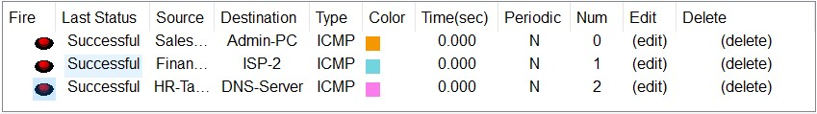

*Figure 2: ICMP PDU check*

**Verification of Redundancy and Failover:** The hierarchical design with redundancy at every layer, including multiple routers, multilayer switches, and ISP connections, was tested to verify failover mechanisms and ensure network resilience.

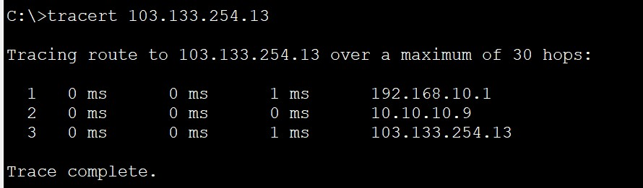

*Figure 3: traceroute successful*

* **DHCP and IP Address Allocation:** Dynamic Host Configuration Protocol (DHCP) functionality and IP address allocation were tested to ensure that devices received the correct IP addresses dynamically and that devices in the server room had static IP assignments.

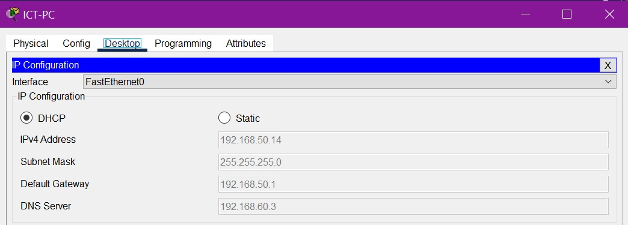

*Figure 4: DHCP IP allocation*

## Troubleshooting

During the testing phase, several common troubleshooting steps were taken to address issues:

* **Device Connectivity:** Ensured that all devices could communicate within their respective VLANs and across different departments. Verified inter-VLAN routing configurations on multilayer switches.
* **DHCP Issues:** Investigated and resolved any DHCP-related issues, ensuring that DHCP servers were reachable and capable of assigning IP addresses to devices dynamically.
* **Routing Configuration:** Verified the Open Shortest Path First (OSPF) routing configurations on routers and multilayer switches, ensuring proper routing table updates and communication between different departments.

**Access Control Issues:** Reviewed and adjusted Access Control Lists (ACLs) to allow necessary traffic and deny unauthorized access.

* **Port Security:** Verified the configuration of port security on the Finance department's switchports to ensure that only one device could connect per port and that MAC addresses were correctly learned.

# Results and Evaluation

## Performance Metrics

Performance metrics, including network latency, throughput, redundancy testing, DHCP response time, inter-VLAN routing performance, security, QoS, and NAT/PAT functionality, were measured during testing to ensure optimal network operation.

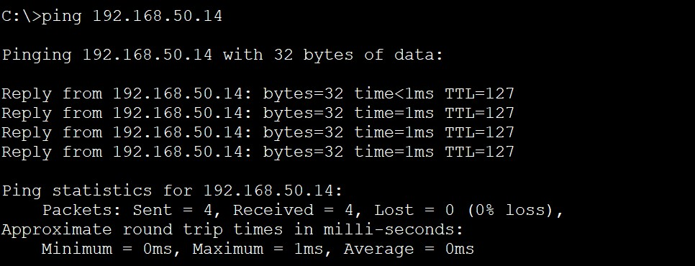

*Figure 5: performance measure through ping time*

## Achievement of Objectives

* **Hierarchical Network Design:**
  + Successful implementation.
* **Redundancy:**o Backup routers, multilayer switches, and dual ISP connections.
* **Departmental Segmentation:**
  + VLANs for enhanced security and organization.
* **Inter-VLAN Routing:**o Configured on multilayer switches.
* **Security Measures:**
  + ACLs, port-security, SSH for access control.
* **NAT and PAT Configurations:**o Effective private-to-public IP address translation.
* **Quality of Service (QoS):**
  + Prioritization of voice and video traffic.
* **Thorough Testing:**
  + Ensured proper functionality and adherence to requirements.

**Overall Objectives Met:**

* + Scalable, secure, and efficient network infrastructure for the trading floor support center.

# Conclusion

## Summary

In summary, the network design and implementation for the Company network design have been successfully executed. Key achievements include a hierarchical network model with redundancy at multiple layers, departmental segmentation through VLANs, inter-VLAN routing, robust security measures, effective NAT and PAT configurations, and Quality of Service (QoS) prioritization. Thorough testing using Cisco Packet Tracer ensured proper functionality and alignment with project requirements. The resulting network provides scalability, security, and efficiency, meeting the specified needs of the organization.

## Lessons Learned

Throughout the project, several valuable lessons have been learned:

* **Redundancy is Key:** The inclusion of redundancy at various levels is crucial for maintaining network availability and minimizing downtime.
* **Effective VLAN Design:** Proper VLAN segmentation enhances security and facilitates organizational structure, simplifying network management.
* **Thorough Testing Matters:** Rigorous testing using simulation tools like Cisco Packet Tracer is essential to identify and rectify issues before deployment.
* **Security is a Priority:** Robust security measures, including ACLs and port-security, are fundamental in safeguarding the network against unauthorized access.
* **Scalability Considerations:** Designing the network with scalability in mind allows for future growth and expansion without significant overhauls.
* **Documentation is Essential:** Comprehensive documentation of configurations, IP addressing, and design decisions streamlines troubleshooting and future modifications.

# References

**Websites:**

[1] https://en.wikipedia.org/wiki/Packet_Tracer

[2] https://www.paessler.com/it-explained/server

[3] https://en.wikipedia.org/wiki/Small_Form-factor_Pluggable

[4] http://router.over-blog.com/article-how-to-configure-cisco-router-password-

106850439.html

[5] https://www.cognoscape.com/benefits-going-wireless/

[6] https://en.wikipedia.org/wiki/Category_6_cable

**Books:**

[1] Cisco Networking Academy - Routing and Switching Essentials v6 Companion Guide

(2016)

[2] Forouzan – TCP/IP Protocol Suite 4E

[3] Computer Networking – A Top-Down Ap

# Appendices

Abbreviations:

ACL - Access Control List

DHCP - Dynamic Host Configuration Protocol

IP - Internet Protocol

OSPF - Open Shortest Path First

PAT - Port Address Translation

QoS - Quality of Service

SSH - Secure Shell

VLAN - Virtual Local Area Network